5 jeks ieish
wfma k.rfha wd.u weoySfï fyda úYajdi oeÍfï ksoyi

bosßm;a lsÍu i|yd l:k msgm;
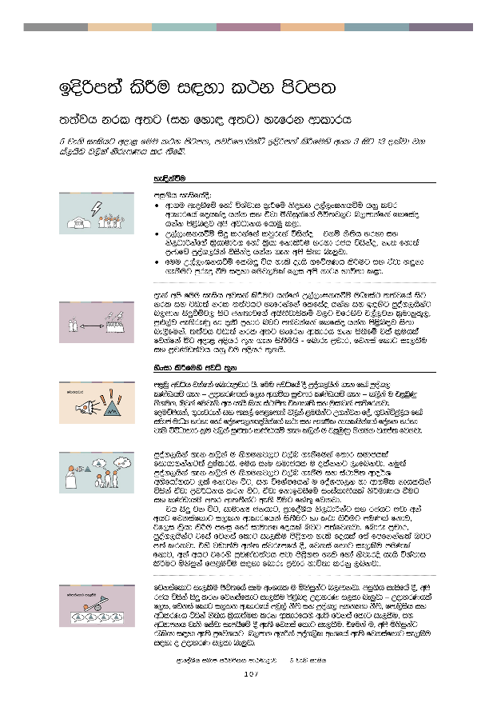
bosßm;a lsÍu i|yd l:k msgm;

;;ajh krl w;g ^iy fyd| w;g& yefrk wdldrh

5 jeks ieishg wod< fuu l:k msgm;" mj¾fmdhskaÜ bosßm;a lsÍfuys wxl 3 isg 13 olajd jk ia,hsv j,ska ksrEmKh lr ;sfí'

 | ye|skaùu
miq.sh ieisfha§(
- wd.u weoySfï fyda úYajdi ±Ífï ksoyi W,a,x>khùï hkq ljr wdldrfha fohlao hkak iy tajd ñksiqkaf.a Ôú;j,g n,mdkafka flfiao hkak ms<sn|j wms wjOdkh fhduq l<d'
- W,a,x>khùï isÿ lrkafka ljqreka úiskao – tkï kS;sh yryd iy ks,OdÍkaf.a l%shdud¾. fyda l%shd fkdlsÍu yryd rch úiskao" ke; fyd;a m%cdfõ mqoa.,hska úiskao hkak .ek wms is;d ne¨jd'
- fuu W,a,x>khùï fln÷ úh yels oehs .fõIKh lsÍug iy tajd y÷kd .ekSug mqreÿ ùu i|yd fuj,ula f,i wms kdgH Ndú;d l<d'

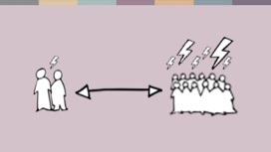 | oeka wms fuu ieish wjika lsÍug hkafka W,a,x>khùï uOHia: ;;ajfha isg krl iy jvd;a krl ;;ajhg yefrkafka flfiao hkak iy b|ysg mqoa.,hskag n,mdk isÿùïj, isg ck;djf.a whs;sjdislï j,g tfrysj t,a,jk l%udkql+," mq¿,aj me;sreKq yd ±ä m%ydr njg m;ajkafka flfiao hkak ms<sn|j is;d ne,Sfuka' ;;ajh jvd;a krl w;g yefrk wdldrh .ek is;Sfï tla l%uhla fjkafka óg wod< wÈhr ;=k .ek is;Suhs - fndre m%pdr" fjkia fldg ie,lSu iy m%pKav;ajh hkq tu wÈhr ;=khs'
 | ysxid lsÍfuys wjê ;=k
 | m<uq wjêh jkafka fndrem%pdr hs' fuu wjêfha oS mqoa.,hska .ek fyda mqoa., lKavdhï .ek – WodyrKhla f,i wd.ñl iq¿;r lKavdhï .ek – l,ska u t<UqKq ks.uk" Tjqka fujeks wh hehs lshd ia:dms; taldlD;s iy uqidjka me;sfrkjd' fouõmshka" .=rejreka iy mdi,a fm<fmd;a j,ska <uhskag W.kajk foa" .=jkaúÿ,sh fyda iudc udOH yryd fyda foaYmd,k{hskaf.a l:d iy wd.ñl kdhlhskaf.a foaYk yryd jeks úúOdldr l%u j,ska iq¿;r lKavdhï .ek l,ska u t<UqKq ks.uk jHdma; fjkjd'
mqoa.,hska .ek l,ska u ks.ukj,g t,an .ekSfuka f;dr iudchla fidhd.kakg;a ÿIalrhs' fuh iEu iudchl u olakkg ,efnkjd' kuq;a mqoa.,hska .ek l,ska u ks.ukj,g t,an .ekSu iy ia:dms; wdo¾Y wNsfhda.hg ,la fkdjk úg" iy úfYaIfhka u foaYmd,k yd wd.ñl kdhlhska úiska tajd m%j¾Okh lrk úg" tajd fkdbjiSfï ixialD;shla ks¾udKh ùug iy lKavdhï w;r wd;;Skag we;s ùug fya;= fjkjd'
th isÿ jk úg" idudkH ckhdg" m%dfoaYSh ks,OdÍkag iy rchg mjd wka whg fjkiafldg i,lk wdldrfhka is;Sug yd l:d lsÍug muKla fkdj" tf,i l%shd lsÍu myiq fyda idudkH fohla njg m;afjkjd' fndre m%pdr" mqoa.,hskag tfia fjkia fldg ie,lSu ms<s.; yels fohla fia fmfkkakla njg m;a lrkjd' tys jvd;au wka; iajrEmfha §" fjkia fldg ie,lSu muKla fkdj" wka whg tfrys m%pKav;ajh mjd ms<s.; yels fyda ksjerÈ hehs úYajdi lsÍug ñksiqka fm<Uùu i|yd fndre m%pdr Ndú;d lrkq ,nkjd'

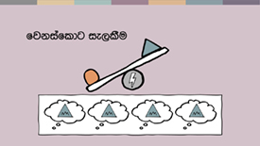 | fjkiafldg ie,lSu Ôú;fha iEu wxYhl u ñksiqkag n,mdkjd' miq.sh ieisfha §" wms rch úiska isÿ lrk fjkiafldg ie,lSu ms<sn| WodyrK i,ld ne¨‍jd – WodyrKhla f,i" fjkia fldg i,lk wdldrfha mjq,a kS;s iy mqoa., wkkH;d kS;s" fmd,sish iy wêlrKh úiska kS;sh l%shd;aul lrk wdldrfhys we;s fjkia fldg ie,lSu" iy wOHdmkh jeks fiajd iemhSfï § we;s fjkia fldg ie,lSu' tfuka u" wms ñksiqkag /lshd i|yd we;s m%fõYhg n,mdk whqßka mqoa.,sl wxYfha we;s fjkiafldg ie,lSu i|yd o WodyrK i,ld ne¨jd'  lsisu iudchla fjkia fldg ie,lSfuka f;dr iudchla fjkafka keye" kuq;a mq¿,a yd l%udkql+, fjkiafldg ie,lSula mej;sh yelafla th fkdoekqj;alu yd fkdßiaiSu ms<sn| ixialD;shla u; f.dvkeÕ=‍Kq úg muKhs' nyq;rhla fokd fjkiafldg ie,lSu ms<s.kafka ke;s kï th È.ska È.g u isÿ fjkafka keye'
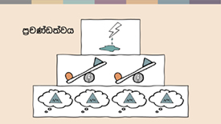 | fndre m%pdr" fjkia fldg ie,lSu i|yd mokula ks¾udKh lrkjd fiau" fndre m%pdr iy fjkia fldg ie,lSu tlg tlajQ úg" m%pKav;ajhg o wä;d,ula imhd fokjd' m%cdj ;=< isÿ jk m%pKav;ajh foam< úkdY lsÍfñ isg ysßyer lsÍï" iy YdÍßl ysxikh ms<sn| ;¾ckh lsÍï olajd jQ úúOdldr iajrEm .; yelshs' rdcH m%pKav;ajhg w;a;fkdau;sl f,i isr.; lsÍu" jOysxid meñKùu iy ia;%S mqreI iudcNdjh u; mokï jQ m%pKav;ajh wdÈh we;=<;a úh yelshs'
 | úYd,;ajh" jdr .Kk iy n,mEu
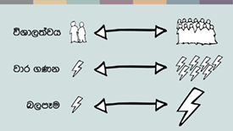 | .eg¿ j¾. ;=k u" – tkï" fndre m%pdr" fjkia fldg ie,lSu iy m%pKav;ajh isÿjk mßudKh" jdr.Kk iy n,mEï we;sjk uÜgï" úúOdldr úh yelshs' W,a,x>khùula mqoa.,hska lsysm fofkl=g fyda úYd, lKavdhïj,g n,mE yelshs' th b|ysg" ks;sm;d fyda l%udkql+,j isÿ úh yelshs – thska woyia jkafka th iudcfha moaO;s yd jHqyhka ;=<g ld jeoS we;s njhs' n,mEug ,lajk ck;djg bka iSñ; fyda úkdYldÍ n,mEula we;s l< yelshs'
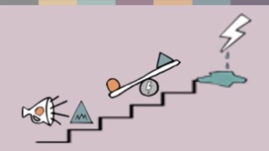 | fndfyda rgj, w;aoelSï wmg mjikafka wúpdrl ye`.Sï iy fndre m%pdr jvd;a mq¿,aj me;sreKq yd jvd;a oeä jk ;rug" fjkiafldg ie,lSu o jvd;a mq¿,aj me;sreKq yd oeä njg m;ajk nj;a" fï folu jvd;a mq¿,a jk ;rug mq¿,a yd oreKq m%pKav;ajhg we;s bvlv o jvd;a jeä jk nj;a h' tla fohla ;j;a fohlg fya;= fjhs' fuh l,lsÍu we;slrjkakla f,i ±lsh yels kuq;a" foaj,a krl w;g yefrkafka flfiao hkak wjfndaO lr .ekSu foaj,a hym;a w;g yefrkafka flfia oehs is;d ne,Sug o wmg WmldÍ fjhs'
 | iudma;sh
iEu fohlau wdrïN jkafka wms tlsfkld ms<sn|j is;k m;k yd l:d lrk wdldrfhka' tA iïnkaOfhka wms iEu flfkl=g u wmf.a mjq,a ;=< iy wmf.a mqoa.,sl cd, ;=< hïlsis fohla l< yelshs' tfuka u wmg m%cd uÜgñka o – WodyrKhla f,i wmf.a wd.fï m%cdjka" mdi,a iy fiajd ia:dk iïnkaOfhka o – ta ms<sn|j hula l< yels fjkakg;a bv ;sfnkjd'
we;a; jYfhka u" fuh m%udKj;a keye' wms ñksiqkag fjkia fldg i,lk yd ydks lrk wdldrfha ks, l%ufõo" tkï krl kS;sj, isg mdi,a .=rejreka fyda fmd,sia ks,OdÍka jeks ks,OdÍkaf.a yeisÍu olajd jQ foa fjkia l< hq;=hs'

 | tjeks fjkila isÿ lsÍu yels lrjkq msKsi wmg ;ukaf.a whs;sjdislï ms<sn|j okakd iy ;uka fjkqfjka fmkS isàug wjYH yelshd j,ska ikakoaO iq¿;rhka" Tjqka iu. ke.S isàug iQodkïj isák nyq;rhka iy udkj ysñlï j,g .re lsÍu" tajd wdrlaId lsÍu iy m%j¾Okh lsÍu i|yd ;uka i;= jk j.lSï wjfndaO lr.;a foaYmd,k yd wd.ñl kdhlhska wjYH hs' fuh h:d¾:hla njg m;a lsÍu fifuka isÿjk" ÿIalr l%shdj,shla'
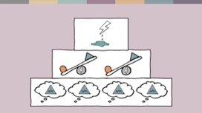 | tu l%shdj,sh wdrïN fjkafka wms wmf.a miqìu úYaf,aIKh lr tys we;s .eg¿ fudkjd oehs y÷kd.;a úghs' tfia lsÍu i|yd wmsg fuu wjê ;=k" tkï fndre m%pdr – fjkia fldg ie,lSu – m%pKav;ajh hk ;=fkka iukaú; wdlD;sh Ndú;d l< yelshs'
ia;=;sh
fuu msgm; fcdydka lekafv,ska ^Johan Candelin) úiska ilia lrk ,o zmSvdlsÍfï wdlD;sfhys wjê ;=kZ u; mokï fõ'

